Week 3 - My Day
Grade 5 | Week 3 | Unit 1
Name: ..............................
Part A - Daily Routines and Present Simple: to be (17 Questions)
▶ A1. Choose the correct form of 'be' (am / is / are).
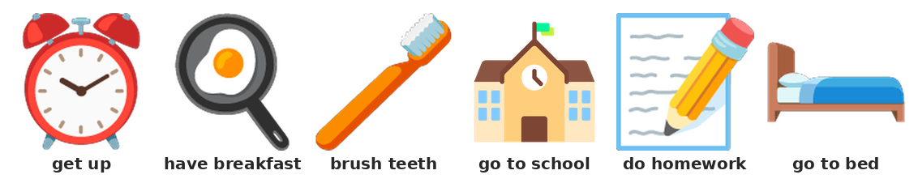
Daily routines
1) I ___ a student.
A) am | B) is | C) be | D) are
2) She ___ happy.
A) am | B) is | C) be | D) are
3) They ___ at school.
A) is | B) be | C) are | D) am
4) 'Are you ready?' - 'Yes, I ___.'
A) is | B) do | C) are | D) am
5) 'Is she tired?' - 'No, she ___.'
A) isn't | B) don't | C) am not | D) aren't
▶ A2. Complete the sentence with the correct verb.
6) I ___ up at seven.
A) walk | B) wake | C) have | D) wakes
7) She ___ breakfast at eight.
A) having | B) have | C) has | D) haves
8) I ___ my teeth.
A) brushing | B) brushes | C) wash | D) brush
9) He ___ to school.
A) goes | B) go | C) walk | D) bed
10) I ___ my homework after dinner.
A) does | B) do | C) doing | D) make
11) She ___ her homework.
A) do | B) doing | C) does | D) make
12) We ___ breakfast at eight.
A) has | B) haves | C) having | D) have
13) I go to ___ at nine o'clock.
A) bed | B) beds | C) bedroom | D) school
▶ A3. Choose the correct question or sentence.
14) 'Do you brush your teeth?' - 'Yes, I ___.'
A) am | B) do | C) does | D) are
15) 'Does she go to school?' - 'Yes, she ___.'
A) are | B) do | C) does | D) is
16) Which sentence is correct?
A) I is at school. | B) I at school. | C) I are at school. | D) I am at school.
17) ___ you ready? (choose the correct word)
A) Are | B) Do | C) Is | D) Am
Part B - Object Pronouns (12 Questions)
▶ B1. Choose the correct object pronoun.
18) Give the book to ___. (I)
A) I | B) me | C) my | D) mine
19) I like ___. (she)
A) he | B) hers | C) her | D) she
20) Please help ___. (he)
A) her | B) his | C) he | D) him
21) I see ___. (they)
A) them | B) they | C) theirs | D) their
22) Give it to ___. (we)
A) ours | B) us | C) we | D) our
23) 'Where is my pen?' - 'I have ___.' (the pen)
A) they | B) its | C) it | D) them
24) 'Do you like my book?' - 'Yes, I like ___.' (the book)
A) they | B) them | C) its | D) it
25) Give the pencils to the girls. Give ___ to the girls.
A) them | B) they | C) their | D) it
▶ B2. Choose the correct sentence.
26) Which sentence is correct?
A) I like he. | B) I like her. | C) I like she. | D) I like his.
27) Which sentence is correct?
A) Help he's. | B) Help his. | C) Help him. | D) Help he.
28) Match:
1. I | ( ) | A) them
2. he | ( ) | B) us
3. she | ( ) | C) me
4. we | ( ) | D) him
5. they | ( ) | E) her
29) 'Do you see Sara?' - 'Yes, I see ___.'
A) she | B) hers | C) him | D) her
Part C - Time Expressions (11 Questions)
▶ C1. Choose 'at', 'in' or 'on'.
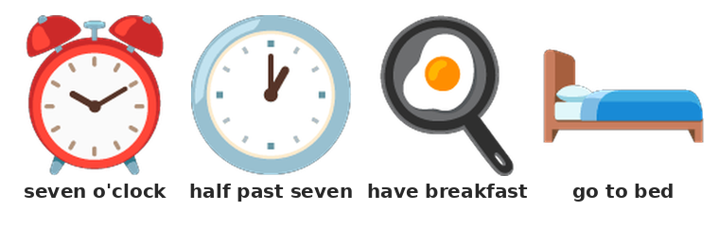
Time
30) I get up ___ seven.
A) at | B) on | C) of | D) in
31) I have breakfast ___ the morning.
A) on | B) in | C) of | D) at
32) I go to bed ___ night.
A) in | B) on | C) at | D) of
33) 'What time is it?' - 'It is seven ___.'
A) clock | B) half | C) past | D) o'clock
34) It is half ___ seven.
A) past | B) half | C) at | D) o'clock
35) I get up ___ school.
A) in | B) before | C) at | D) after
36) I do my homework ___ dinner.
A) at | B) in | C) after | D) before
37) 'It is seven o'clock.' - What time is it?
A) eight o'clock | B) half past seven | C) six o'clock | D) seven o'clock
38) Which sentence is correct?
A) I get up before school. | B) I get up before the school. | C) I get up school before. | D) Before I get up school.
39) Which sentence is correct?
A) It is seven half past. | B) It is half past seven. | C) It is past half seven. | D) It is half seven past.
40) I go to bed in the morning.
( ) True ( ) False
Part D - Body Parts (10 Questions)
▶ D1. Choose the correct body part.
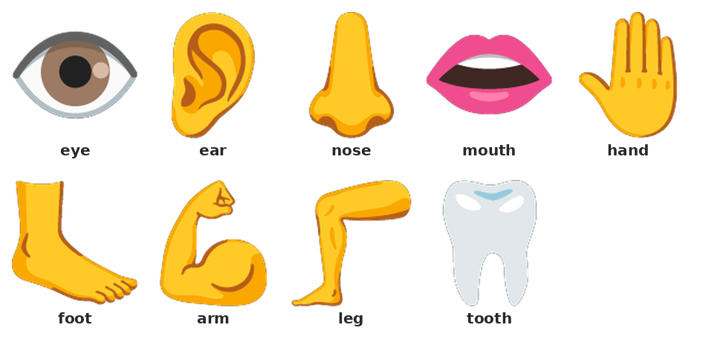
Body parts
41) We see with our ___.
A) mouth | B) ears | C) eyes | D) nose
42) We hear with our ___.
A) eyes | B) mouth | C) hands | D) ears
43) We smell with our ___.
A) nose | B) ear | C) mouth | D) eye
44) We eat with our ___.
A) eye | B) mouth | C) nose | D) ear
45) We have two ___.
A) foot | B) hand | C) hands | D) tooth
46) We have two ___.
A) hand | B) tooth | C) foot | D) feet
47) Head, shoulders, knees and ___.
A) toes | B) toe | C) nose | D) hair
48) We walk with our ___.
A) hand | B) legs | C) arm | D) leg
49) We write with our ___.
A) hands | B) eye | C) hand | D) foot
50) We have 32 ___.
A) eyes | B) tooth | C) nose | D) teeth
Part E - Writing (6 Questions)
▶ E1. Match the routine and the time.
51) Match:
1. get up | ( ) | A) nine o'clock at night
2. have breakfast | ( ) | B) after dinner
3. go to school | ( ) | C) seven o'clock
4. do homework | ( ) | D) eight o'clock
5. go to bed | ( ) | E) nine o'clock
▶ E2. Write the answers.
52) Write three things you do in the morning.
_____________________________________________________________________________________________
_____________________________________________________________________________________________
53) Write about your day. Use 'before' and 'after'.
_____________________________________________________________________________________________
_____________________________________________________________________________________________
_____________________________________________________________________________________________
54) Write what time you get up.
_____________________________________________________________________________________________
_____________________________________________________________________________________________
55) Write about your body. Use 'I have got'.
_____________________________________________________________________________________________
_____________________________________________________________________________________________
_____________________________________________________________________________________________
_____________________________________________________________________________________________

