Week 3 - My School
Grade 4 | Week 3 | Unit 1
Name: ..............................
Part A - Present Continuous (17 Questions)
▶ A1. Choose the correct form of 'be' (am / is / are).
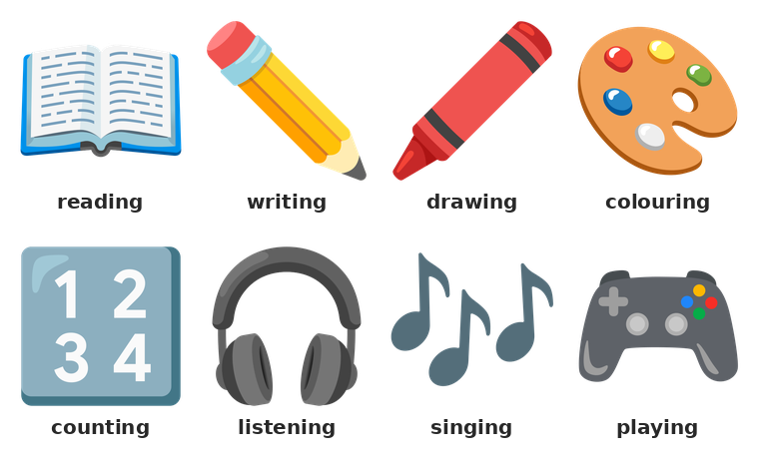
What are they doing?
1) I ___ reading a book.
A) am | B) is | C) be | D) are
2) She ___ writing.
A) am | B) is | C) be | D) are
3) They ___ playing football.
A) is | B) be | C) are | D) am
4) He ___ singing.
A) am | B) be | C) are | D) is
5) We ___ listening.
A) are | B) be | C) is | D) am
▶ A2. Choose the correct word to complete the sentence.
6) What is she ___?
A) reading | B) doing | C) writing | D) playing
7) She is ___ a picture.
A) counting | B) reading | C) drawing | D) singing
8) They are ___ numbers.
A) singing | B) drawing | C) playing | D) counting
9) I am ___ a book.
A) reading | B) drawing | C) counting | D) playing
10) He is ___ a song.
A) drawing | B) singing | C) reading | D) counting
▶ A3. Circle the correct sentence or short answer.
11) Which sentence is correct?
A) She is swim. | B) She swimming. | C) She is swimming. | D) She are swimming.
12) Which sentence is correct?
A) I reading. | B) I is reading. | C) I are reading. | D) I am reading.
13) Which question is correct?
A) What is he doing? | B) What he is doing? | C) What doing he is? | D) What does he doing?
14) 'Is he colouring?' - 'Yes, he ___.'
A) am | B) is | C) are | D) do
15) 'Are you writing?' - 'No, I ___.'
A) don't | B) isn't | C) am not | D) aren't
16) 'What are you doing?' - 'I ___ a book.'
A) are reading | B) is reading | C) do reading | D) am reading
17) 'What are they doing?' - 'They ___ football.'
A) are playing | B) play playing | C) is playing | D) am playing
Part B - School Subjects and Timetable (14 Questions)
▶ B1. Choose the correct school subject.
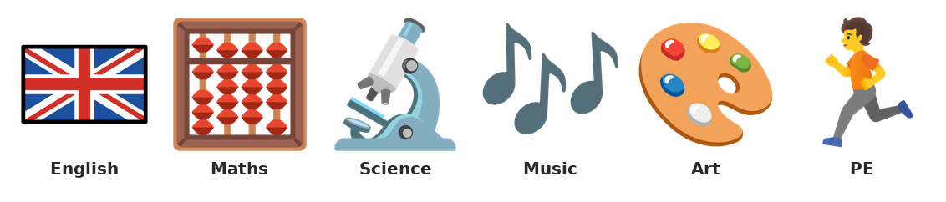
School subjects
18) We count and use numbers in ___.
A) Art | B) Maths | C) Music | D) PE
19) We draw and colour pictures in ___.
A) English | B) Science | C) Art | D) Maths
20) We run and play games in ___.
A) Maths | B) Art | C) Music | D) PE
21) We sing songs in ___.
A) Music | B) Science | C) Maths | D) PE
22) There are seven days in a ___.
A) school | B) week | C) day | D) class
23) We read and write English words in ___.
A) Art | B) PE | C) English | D) Maths
▶ B2. Look at the timetable and answer the questions.
Day | Subject
Monday | English
Tuesday | Maths
Wednesday | Music
Thursday | Science
Friday | PE

24) Which subject is on Monday?
A) PE | B) Maths | C) Music | D) English
25) Which subject is on Wednesday?
A) Music | B) English | C) Art | D) Science
26) On which day is PE?
A) Tuesday | B) Friday | C) Monday | D) Wednesday
27) On which day is Science?
A) Tuesday | B) Friday | C) Thursday | D) Wednesday
28) Which day comes after Monday?
A) Monday | B) Friday | C) Wednesday | D) Tuesday
29) Which day comes before Friday?
A) Thursday | B) Monday | C) Wednesday | D) Saturday
30) On Monday I ___ English.
A) is | B) have | C) are | D) has
31) Music is on Tuesday.
( ) True ( ) False
Part C - There is / There are (10 Questions)
▶ C1. Complete the sentence with 'is' or 'are'.
32) There ___ a board in the classroom.
A) are | B) am | C) is | D) be
33) There ___ twenty desks.
A) is | B) am | C) be | D) are
34) There ___ a computer in the office.
A) is | B) am | C) be | D) are
35) There ___ two doors.
A) be | B) are | C) am | D) is
36) There ___ a library in the school.
A) am | B) be | C) is | D) are
▶ C2. Choose the correct question or sentence.
37) ___ there a library in the school?
A) Am | B) Are | C) Do | D) Is
38) ___ there books on the table?
A) Are | B) Is | C) Am | D) Do
39) Which sentence is correct?
A) There ten chairs. | B) There are ten chairs. | C) There are ten chair. | D) There is ten chairs.
40) Which sentence is correct?
A) There is board a. | B) There are a board. | C) There is a board. | D) There a board.
41) There is ___ book on the table.
A) an | B) the | C) two | D) a
Part D - My, Your, His, Her, Our, Their (10 Questions)
▶ D1. Choose the correct word.
42) This is ___ book. (Ali)
A) Ali's | B) Ali s | C) Ali | D) Alis
43) This is ___ pencil. (I)
A) I | B) my | C) me | D) us
44) She is my teacher. ___ name is Sara.
A) My | B) His | C) Her | D) Their
45) He is my friend. ___ name is Ali.
A) My | B) Your | C) Her | D) His
46) We are in ___ classroom.
A) our | B) us | C) we | D) ours
47) 'Is this ___ ruler?' (you)
A) me | B) your | C) I | D) you
48) They are my friends. ___ names are Ali and Sara.
A) His | B) Our | C) Their | D) Her
49) It is ___ door. (the school)
A) their | B) it | C) they | D) its
50) 'Whose book is this?' - 'It is ___ book.' (Sara)
A) Sara's | B) Sara s | C) Saras | D) Sara
51) Which is correct?
A) Alis pencil | B) Ali's pencil | C) pencil Ali | D) Ali pencil
Part E - Can I / May I (8 Questions)
▶ E1. Choose 'Can', 'May' or the correct short answer.
52) ___ I go out, please?
A) Is | B) Am | C) Can | D) Do
53) ___ I use your pencil?
A) Are | B) Is | C) Am | D) May
54) 'Can I open the window?' - 'Yes, you ___.'
A) can | B) do | C) are | D) is
55) 'May I come in?' - 'Yes, you ___.'
A) do | B) may | C) is | D) are
56) ___ I sit down, please?
A) Do | B) Are | C) Can | D) Is
57) ___ I close the door?
A) Is | B) Do | C) Are | D) May
58) Which sentence is correct?
A) Can I go out, please? | B) Go out I. | C) I go out. | D) You go out.
59) 'Can I use your ruler?' - 'Yes, you ___.'
A) do | B) can | C) are | D) is
Part F - Writing (6 Questions)
▶ F1. Match the subject and what we do.
60) Match:
1. Maths | ( ) | A) read words
2. Music | ( ) | B) draw pictures
3. PE | ( ) | C) count numbers
4. Art | ( ) | D) sing songs
5. English | ( ) | E) run and play
▶ F2. Write the answers.
61) Write three subjects you have at school.
_____________________________________________________________________________________________
_____________________________________________________________________________________________
62) Write about your classroom. Use 'There is' and 'There are'.
_____________________________________________________________________________________________
_____________________________________________________________________________________________
_____________________________________________________________________________________________
63) Write what you are doing now. Use 'I am ___-ing'.
_____________________________________________________________________________________________
_____________________________________________________________________________________________
64) Write about your timetable. What do you have on Monday and Friday?
_____________________________________________________________________________________________
_____________________________________________________________________________________________
_____________________________________________________________________________________________
_____________________________________________________________________________________________

