Grade 4 - Unit 1: There is / There are
There is / There are - Count, Fill, Choose, Answer
Ad Soyad: ..............................
Konu Anlatimi - There is / There are
DIKKAT: Tek nesne -> There is a book. | Cok nesne -> There are two books.

There is + tekil isim: There is a pen. There are + cogul isim: There are three pens.
EXAMPLE
___ a board in the classroom.
Çözüm:
1. Tek nesne var -> is
2. There is a board in the classroom.

EXAMPLE
___ two windows in the classroom.
Çözüm:
1. Iki nesne var, cogul -> are
2. There are two windows in the classroom.

Bolum 1 - Look at the Pictures
▶ Look at the picture. Choose There is or There are.
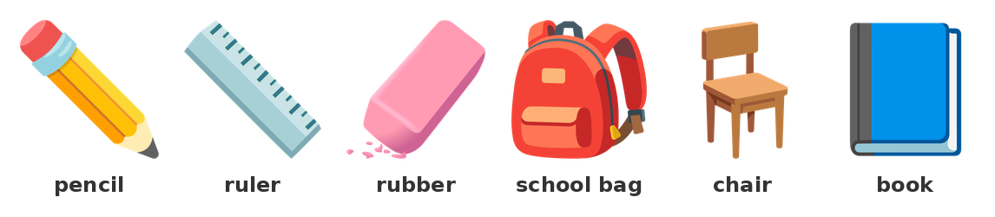
Look: pencil, ruler, rubber, school bag, chair, book
1) How many rubbers are there? There ___ one rubber.
A) is | B) are | C) am | D) be
2) How many objects are there? There ___ six objects.
A) is | B) are | C) am | D) be
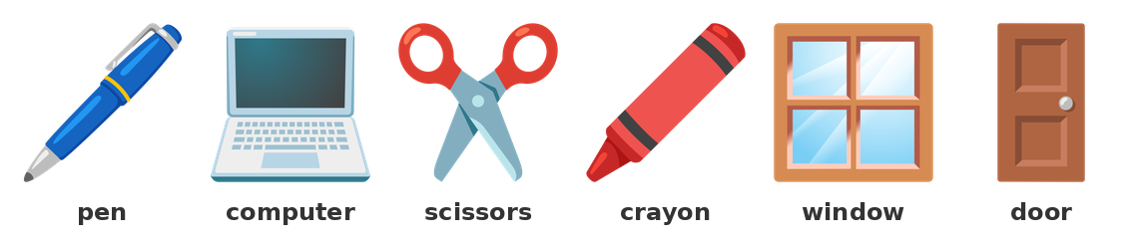
Look: pen, computer, scissors, crayon, window, door
3) How many pens are there? ___ one pen.
A) There is
B) There are
C) It is
D) They are
4) How many objects are there? ___ six objects.
A) There is
B) It is
C) There are
D) Are there
Bolum 2 - Fill in the Blanks (is / are)
▶ Fill in the blanks with is or are.
5) There ________ a door in the classroom.
There __________ two windows in the classroom.
6) There __________ three books on the table.
There ________ a computer in the room.
7) There ________ a board in the classroom.
There __________ six chairs in the room.
REMEMBER: Tek isim: a book, one book -> is. Cogul isim: two books -> are.

8) There ________ a pen in the school bag.
There __________ five pencils in the school bag.
9) There ________ one library in the school.
There __________ two playgrounds in the school.
Bolum 3 - One or More?
▶ Count and fill in the blanks.
10) There ________ a computer.
There __________ two computers.
11) There ________ a book.
There __________ ten books in the library.
12) There ________ a door.
There __________ four doors in the school.
13) There ___ a table in the canteen.
A) is | B) are | C) am | D) be
14) There ___ eight windows in the classroom.
A) is | B) are | C) am | D) be
Bolum 4 - Negative: isn't / aren't
DIKKAT: Olumsuz: There isn't a pen. (tek) | There aren't two pens. (cok)

EXAMPLE
There ___ a computer in the classroom. (not)
Çözüm:
1. Tek nesne -> is
2. Olumsuz -> is + not = isn't
3. There isn't a computer in the classroom.

15) There ______________ a library in the school. (not)
There ________________ two boards in the room. (not)
16) There ________________ six students in the classroom. (not)
There ______________ a ball in the school bag. (not)
17) There ___ five windows in the classroom. (not)
A) isn't | B) aren't | C) is | D) are
18) There ___ a table in the playground. (not)
A) isn't | B) aren't | C) is | D) are
19) There isn't two books in the bag.
( ) Doğru ( ) Yanlış
20) There aren't three chairs in the room.
( ) Doğru ( ) Yanlış
21) There isn't a door in the classroom.
( ) Doğru ( ) Yanlış
Bolum 5 - Question: Is there / Are there?
REMEMBER: Soru: Is there a pen? | Are there two pens?

EXAMPLE
___ there a library in the school?
Çözüm:
1. Tek nesne -> Is there
2. Is there a library in the school?

22) ________ there a door in the classroom?
__________ there two windows in the classroom?
23) ___ there a playground in the school? Yes, there is.
A) Is | B) Are | C) Am | D) Be
24) ___ there five students in the classroom?
A) Is | B) Are | C) Am | D) Be
25) Is there a book on the table? Yes, there ___.
A) is | B) are | C) isn't | D) aren't
26) Are there two pens in the bag? No, there ___.
A) is | B) are | C) isn't | D) aren't
27) Make a question: ______ a library in the school? (one)
___________________________________________________________________________________________
Bolum 6 - There is / There are + in / on
28) There is a book ________ the table.
29) There are two chairs ________ the room.
30) There is a computer ________ the classroom.
31) There are three books ___ the table.
A) in | B) on | C) at | D) to
32) There is a picture ___ the classroom.
A) in | B) on | C) at | D) under
Bolum 7 - How many ... ?
REMEMBER: How many + cogul isim: How many students are there?

EXAMPLE
___ students are there? Twenty students.
Çözüm:
1. Kac tane -> How many
2. How many students are there?

33) ___ books are there? Five books.
A) How
B) How many
C) What
D) Who
34) ___ chairs are there? Twelve chairs.
A) How many
B) How
C) Where
D) Whose
35) How many books are there? (10)
___________________________________________________________________________________________
36) Is there a library in your school?
___________________________________________________________________________________________
37) Are there two boards in your classroom?
___________________________________________________________________________________________
Bolum 8 - Diyalog Alistirmasi
▶ Read and fill in the blanks.
38) Ali: How many books are there?
Sara: There __________ ten books.
39) Sara: Is there a library in the school?
Ali: Yes, there ________.
40) Tom: Are there two computers in the room?
Leyla: No, there ________________.
Bolum 9 - Karisik Test
▶ Choose the correct answer.
41) There ___ a school bag on the chair.
A) is | B) are | C) am | D) be
42) There ___ three crayons in the bag.
A) is | B) are | C) am | D) be
43) There ___ a computer in the office.
A) is | B) are | C) am | D) be
44) There ___ two playgrounds in the school.
A) is | B) are | C) am | D) be
45) There isn't a ___ in the classroom.
A) chairs
B) windows
C) door
D) books
46) There are eight ___ in the classroom.
A) chair
B) window
C) students
D) board
47) ___ there a playground in the school? Yes, there is.
A) Is | B) Are | C) Am | D) Do
48) How many chairs are there? ___ twelve chairs.
A) There is
B) There are
C) It is
D) Is there
49) There are a book on the table.
( ) Doğru ( ) Yanlış
50) There is a pen in the school bag.
( ) Doğru ( ) Yanlış
51) There isn't three windows in the classroom.
( ) Doğru ( ) Yanlış
Bolum 10 - Writing
52) Write five sentences about your classroom. Use: There is ... / There are ...
___________________________________________________________________________________________
___________________________________________________________________________________________
___________________________________________________________________________________________
___________________________________________________________________________________________
___________________________________________________________________________________________
___________________________________________________________________________________________

