Grade 4 - Unit 1: My School
Çalışma Kitabı | Basitten Karmaşığa | Colours, Objects, Places, To Be, Present Continuous, WH-Questions
Ad Soyad: ..............................
Bölüm 1 — Colours and Numbers
▶ Renkleri ve sayıları tekrar edelim. Resme bak, doğru cevabı seç.
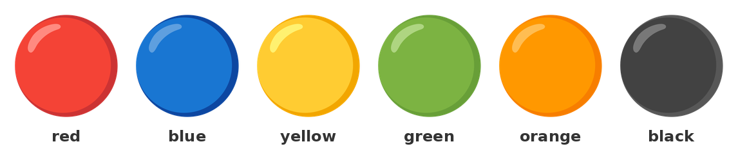
Colours: red, blue, yellow, green, orange, black
1) Eşleştirin:
1. kırmızı | ( ) | A) yellow
2. mavi | ( ) | B) black
3. sarı | ( ) | C) red
4. yeşil | ( ) | D) white
5. siyah | ( ) | E) green
6. beyaz | ( ) | F) blue
▶ Bu renk ne? Doğru kelimeyi seç.

2) What colour is it?
A) red | B) blue | C) yellow | D) green

3) What colour is it?
A) red | B) blue | C) black | D) brown

4) What colour is it?
A) orange | B) green | C) yellow | D) white

5) What colour is it?
A) blue | B) purple | C) red | D) green

6) What colour is it?
A) orange | B) yellow | C) brown | D) pink

7) What colour is it?
A) white | B) black | C) grey | D) blue
▶ Sayıları yazalım. Kelime bankasını kullan.
8) 1 = __________ 2 = __________ 3 = ______________
Kelime bankası: four | two | three | five | one
9) 4 = ____________ 5 = ____________ 6 = __________
Kelime bankası: seven | five | six | eight | four
10) 7 = ______________ 8 = ______________ 9 = ____________ 10 = __________
Kelime bankası: ten | eight | nine | eleven | seven | twelve
11) Eşleştirin:
1. 5 | ( ) | A) nine
2. 7 | ( ) | B) five
3. 9 | ( ) | C) ten
4. 10 | ( ) | D) seven
Bölüm 1b — Numbers 11 to 100
11 = eleven, 12 = twelve, 13 = thirteen, 14 = fourteen, 15 = fifteen, 16 = sixteen, 17 = seventeen, 18 = eighteen, 19 = nineteen, 20 = twenty.
12) 11 = ?
A) twelve | B) ten | C) eleven | D) twenty
13) 15 = ?
A) fifty | B) fourteen | C) five | D) fifteen
14) 18 = ?
A) eighteen | B) eighty | C) eight | D) seventeen
15) 20 = ?
A) twelve | B) twenty | C) two | D) ten
16) 30 = ?
A) thirteen | B) three | C) thirty | D) forty
17) 50 = ?
A) fifteen | B) five | C) sixty | D) fifty
▶ Boşlukları doldur.
18) 20 = ________________ 30 = ________________ 40 = ______________ 50 = ______________
19) 60 = ______________ 70 = __________________ 80 = ________________ 90 = ________________ 100 = __________________
10 | 20 | 30 | 40 | 50
ten | twenty | thirty | forty | fifty

20) 10, 20, 30, 40, 50 ... Write two numbers after 50 (words).
___________________________________________________________________________________________

Bölüm 2 — Classroom Objects
▶ Resme bak ve nesneleri öğren.
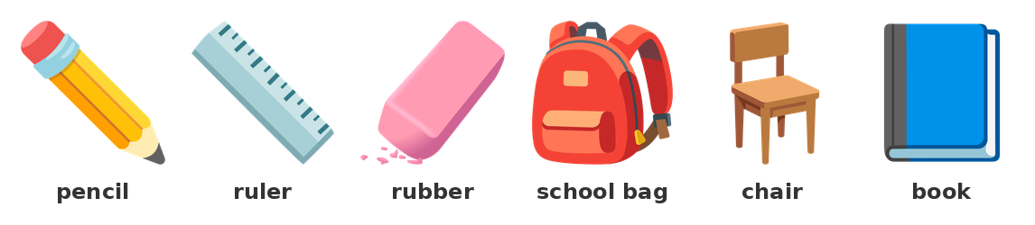
Classroom objects
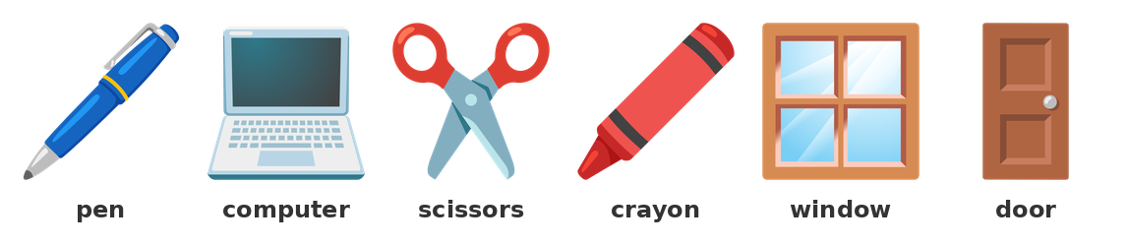
More classroom objects
PÜF NOKTASI: a + sessiz harf: a pen, a book | an + sesli harf: an orange, an eraser

21) Eşleştirin:
1. pencil | ( ) | A) kitap
2. ruler | ( ) | B) silgi
3. rubber | ( ) | C) kalem
4. school bag | ( ) | D) sandalye
5. chair | ( ) | E) okul çantası
6. book | ( ) | F) cetvel
22) We write with a ___.
A) pencil
B) ruler
C) chair
D) window
23) We erase with a ___.
A) pen
B) rubber
C) book
D) door
24) We draw a line with a ___.
A) school bag
B) chair
C) ruler
D) crayon
25) We put our books in a ___.
A) chair
B) window
C) door
D) school bag
26) We sit on a ___.
A) chair
B) book
C) pen
D) ruler
27) We look at it. It is big and black.
A) chair
B) board
C) pen
D) rubber
28) We open it and look out.
A) book
B) door
C) window
D) bag
29) We cut with it.
A) ruler
B) pen
C) book
D) scissors
▶ a / an? Doğru olanı seç.
30) ___ pencil
A) a | B) an | C) the | D) two
31) ___ orange
A) a | B) an | C) the | D) one
32) ___ eraser
A) a | B) the | C) an | D) three
33) ___ book
A) an | B) the | C) one | D) a
34) ___ ruler
A) a | B) an | C) the | D) two
35) ___ object
A) a | B) an | C) the | D) one
36) It is ________ pen. It is ________ ruler. It is ________ orange.
37) I have got ________ book. I have got ________ eraser.
Kelime bankası: an | a | the

Bölüm 2b — Write the Objects
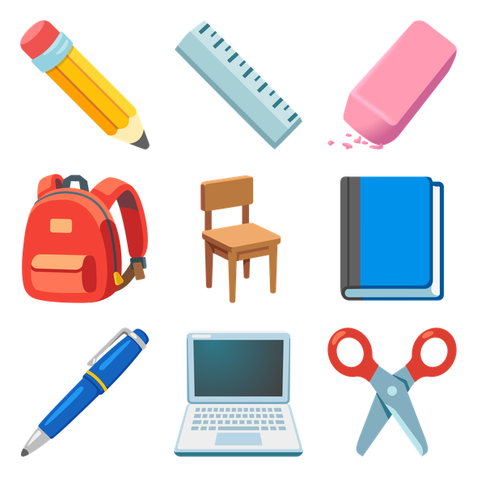
Look and write the words.
38) 1. ___________ 2. ___________ 3. ___________
___________________________________________________________________________________________
39) 4. ___________ 5. ___________ 6. ___________
___________________________________________________________________________________________
40) 7. ___________ 8. ___________ 9. ___________
___________________________________________________________________________________________
DİKKAT: this = yakın (bu) | that = uzak (şu)

41) ___ is a pen. (elimde)
A) That | B) These | C) This | D) Those
42) ___ is a door. (uzak)
A) This | B) These | C) Those | D) That
43) ___ is my chair. (yakınımda)
A) This | B) That | C) Those | D) They
44) ____________ (yakın) is a book.
____________ (uzak) is a window.

Bölüm 3 — School Places, Subjects and Days
▶ Okuldaki yerleri öğren.
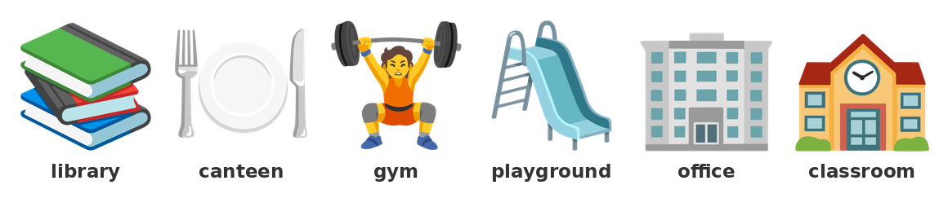
School places
45) Eşleştirin:
1. library | ( ) | A) oyun alanı
2. canteen | ( ) | B) kütüphane
3. gym | ( ) | C) sınıf
4. playground | ( ) | D) yemekhane
5. office | ( ) | E) ofis
6. classroom | ( ) | F) spor salonu
▶ Nerede? Doğru yeri seç.
46) We read books in the ___.
A) gym
B) library
C) canteen
D) office
47) We eat in the ___.
A) library
B) gym
C) canteen
D) office
48) We play football in the ___.
A) library
B) office
C) classroom
D) playground
49) We do PE in the ___.
A) gym
B) canteen
C) library
D) office
50) The teacher is in the ___.
A) playground
B) office
C) canteen
D) gym
51) We read and write in the ___.
A) gym
B) canteen
C) classroom
D) playground
52) We read books in the __________________.
We eat in the __________________.
We play in the ________________________.
Kelime bankası: playground | canteen | gym | library
Subjects
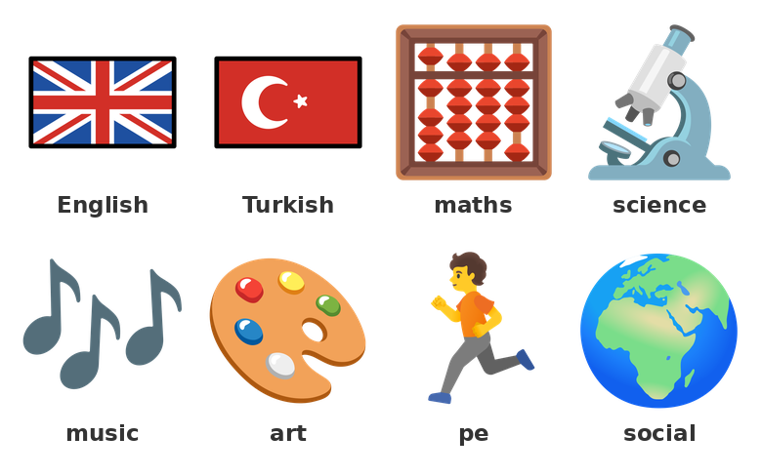
School subjects
Subjects: English, Turkish, maths, science, music, art, PE, social.
53) We count numbers in ___.
A) music
B) art
C) PE
D) maths
54) We sing songs in ___.
A) music
B) maths
C) science
D) PE
55) We draw and colour in ___.
A) science
B) art
C) maths
D) music
56) We speak English in ___.
A) Turkish
B) art
C) English
D) PE
57) We run and jump in ___.
A) music
B) art
C) science
D) PE
Days of the Week
Monday, Tuesday, Wednesday, Thursday, Friday, Saturday, Sunday.
58) 1. ________________
2. __________________
3. ______________________
4. ____________________
5. ________________
6. ____________________
7. ________________
59) Which day is after Monday?
A) Sunday
B) Tuesday
C) Friday
D) Wednesday
60) Which day is before Friday?
A) Saturday
B) Monday
C) Thursday
D) Sunday
61) Which day is the first school day?
A) Sunday
B) Saturday
C) Friday
D) Monday
62) Which day is not a school day?
A) Sunday
B) Monday
C) Tuesday
D) Wednesday

Bölüm 4 — To Be, There is / There are, Have got
PÜF NOKTASI: I am | He/She/It is | You/We/They are — There is a book. / There are two books.

ÖRNEK
___ a book on the table.
Çözüm:
1. Tek nesne var → is
2. There is a book on the table.

▶ am / is / are ile doldur.
63) I ________ a student.
She ________ my teacher.
They __________ in the classroom.
64) We __________ students.
He ________ in the gym.
It ________ a book.
65) You __________ my friend.
My school ________ big.
I ________ happy.
66) ___ you a student?
A) Is | B) Are | C) Am | D) Be
67) ___ she your teacher?
A) Are | B) Am | C) Is | D) Be
68) They ___ my friends.
A) is | B) am | C) be | D) are
69) Ali ___ in the playground.
A) is | B) are | C) am | D) be
70) I ___ nine.
A) is | B) am | C) are | D) be
▶ There is / There are ile doldur.
71) There ________ a board in the classroom.
There __________ two windows.
72) There __________ five books.
There ________ a computer.
73) How many students are there? ___ twenty students.
A) There is
B) It is
C) There are
D) He is
74) How many chairs are there? ___ one chair.
A) There are
B) They are
C) It are
D) There is
▶ have got / has got ile doldur.
75) I ____________ __________ a pen.
She __________ __________ a ruler.
We ____________ __________ two books.
76) He __________ __________ a school bag.
They ____________ __________ a ball.
77) I has got a book.
( ) Doğru ( ) Yanlış
78) She has got a ruler.
( ) Doğru ( ) Yanlış
79) They have got two pens.
( ) Doğru ( ) Yanlış

Bölüm 5 — This / That / These / Those, Whose
PÜF NOKTASI: Tek: this (yakın) / that (uzak) — Cok: these (yakın) / those (uzak)

ÖRNEK
___ are my books. (yakınımda, iki kitap)
Çözüm:
1. Iki kitap → cogul
2. Yakın → these
3. These are my books.

80) Eşleştirin:
1. this | ( ) | A) şu (çoğul)
2. that | ( ) | B) bu (tekil)
3. these | ( ) | C) şu (tekil)
4. those | ( ) | D) bunlar (çoğul)
81) ___ is a pen. (1 tane, yakın)
A) This | B) These | C) Those | D) That
82) ___ is a board. (1 tane, uzak)
A) This | B) That | C) These | D) Those
83) ___ are chairs. (2 tane, yakın)
A) This | B) That | C) These | D) Those
84) ___ are windows. (2 tane, uzak)
A) This | B) That | C) These | D) Those
85) ___ are my friends.
A) These | B) This | C) That | D) It
86) ___ is my classroom.
A) These | B) This | C) Those | D) They
87) ____________ is a ruler. (1, yakın)
______________ are rulers. (2, uzak)
88) ____________ is a chair. (1, uzak)
______________ are chairs. (3, yakın)
Whose — Kimin?
Ali's book = Ali'nin kitabı. Whose book is this? It is Ali's book.
89) ___ book is this? It is Sara's book.
A) Who
B) What
C) Whose
D) Where
90) This is ___ bag. (Sara)
A) Sara
B) Sara is
C) Sara are
D) Sara's
91) This is ___ pen. (Ali)
A) Ali's
B) Ali
C) Ali are
D) Ali have
92) ___ ruler is this? It is Ali's ruler.
A) When
B) Whose
C) How
D) Which
93) This is ______________ (Ali) book.
This is ________________ (Sara) ruler.
94) Whose chair is this? It is Ali's chair. → Whose ___ is this?
___________________________________________________________________________________________

Bölüm 6 — Present Continuous
PÜF NOKTASI: am / is / are + fiil → I am reading. She is writing. They are playing.

▶ Resimlere bak.
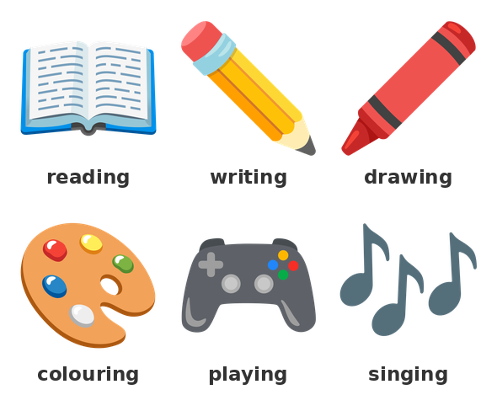
In the classroom
ÖRNEK
Look! She ___ (read) a book.
Çözüm:
1. She → is
2. read → reading
3. She is reading a book.

95) I ________________________ (read) a book.
She ________________________ (write) her name.
96) They __________________________ (play) a game.
He __________________________ (count) the numbers.
97) We ______________________________ (listen) to a song.
The students ______________________________ (colour) the picture.
98) Look! The students ___ a picture.
A) is drawing
B) am drawing
C) are drawing
D) drawing
99) What is she doing? She ___ a book.
A) are reading
B) am reading
C) read
D) is reading
100) What are you doing? I ___ my name.
A) am writing
B) is writing
C) are writing
D) write
101) He ___ a song now.
A) are singing
B) is singing
C) am singing
D) sing
102) They ___ in the playground.
A) is running
B) am running
C) are running
D) run
▶ Olumsuz ve soru şekli.
103) I __________________________________ (not / sleep).
He ________________________________ (not / run).
104) They ____________________________________ (not / swim).
We ____________________________________ (not / watch) a DVD.
105) ___ she writing? Yes, she is.
A) Are
B) Am
C) Does
D) Is
106) Are they playing? No, they ___.
A) are not
B) is not
C) am not
D) not
107) ___ you listening? Yes, I am.
A) Is
B) Are
C) Am
D) Do
108) Is he singing? No, he ___.
A) are not
B) am not
C) is not
D) no
109) She is write a book.
( ) Doğru ( ) Yanlış
110) They are playing football.
( ) Doğru ( ) Yanlış
111) I am reading a book.
( ) Doğru ( ) Yanlış

Bölüm 7 — WH Questions
PÜF NOKTASI: What = ne | Who = kim | Where = nerede | Whose = kimin | How many = kaç tane

ÖRNEK
___ is your teacher? She is in the classroom.
Çözüm:
1. Cevap: yer (in the classroom)
2. → Where

112) ___ is this? It is a ruler.
A) Who
B) Where
C) Whose
D) What
113) ___ is your teacher? She is in the classroom.
A) Where
B) What
C) Who
D) Whose
114) ___ book is this? It is Ali's book.
A) Who
B) Whose
C) What
D) Where
115) ___ students are there? Twelve students.
A) How
B) Who
C) How many
D) What
116) ___ is he doing? He is reading.
A) Who
B) Where
C) Whose
D) What
117) ___ is your name?
A) What
B) Who
C) Where
D) Whose
118) ___ is she? She is my teacher.
A) What
B) Who
C) Where
D) Whose
119) ___ are you? I am in the gym.
A) What
B) Who
C) Where
D) Whose
120) ____________ is this? It is a book.
__________ is your teacher? She is Sara.
121) ______________ book is this? It is Ali's book.
____________________ students are there? Ten.
▶ Soruları kur.
122) Make a question: ______ is ______ ? (name sor)
___________________________________________________________________________________________
123) Make a question: ______ is the library ? (yere sor)
___________________________________________________________________________________________
124) Make a question: ______ book is this ? (kimin)
___________________________________________________________________________________________

Bölüm 8 — Reading and Writing
My name is Ali. I am a student. My school is big. My classroom is small. I have got a pen and a book. My teacher is Sara. She is in the classroom. We read and write in the classroom. We play in the playground. My school is nice.
▶ Metne göre doğru mu, yanlış mı?
125) Ali is a student.
( ) Doğru ( ) Yanlış
126) Ali's school is small.
( ) Doğru ( ) Yanlış
127) Ali has got a pen and a book.
( ) Doğru ( ) Yanlış
128) They play in the gym.
( ) Doğru ( ) Yanlış
▶ Soruları cevapla.
129) Who is Ali's teacher?
___________________________________________________________________________________________
130) Where do they play?
___________________________________________________________________________________________
131) What has Ali got?
___________________________________________________________________________________________
▶ Resme bak ve 5 cümle yaz.
Write about the objects.
132) Write five sentences about the objects in the picture. Use: This is ... / I have got ... / There is ...
___________________________________________________________________________________________
___________________________________________________________________________________________
___________________________________________________________________________________________
___________________________________________________________________________________________
___________________________________________________________________________________________
___________________________________________________________________________________________
133) Write about your school. (name, classroom, teacher, subjects, playground)
___________________________________________________________________________________________
___________________________________________________________________________________________
___________________________________________________________________________________________
___________________________________________________________________________________________
___________________________________________________________________________________________
___________________________________________________________________________________________
Bölüm 8b — Karışık Test (Kolaydan Zora)
134) kırmızı = ?
A) blue
B) green
C) black
D) red
135) It is ___ book.
A) a
B) an
C) the
D) two
136) We read books in the ___.
A) gym
B) library
C) canteen
D) office
137) She ___ my teacher.
A) are
B) am
C) is
D) be
138) ___ are my books.
A) This
B) That
C) It
D) These
139) Look! He ___ a picture.
A) is drawing
B) are drawing
C) am drawing
D) draw
140) ___ is your name?
A) Who
B) What
C) Where
D) Whose
141) This is ___ bag. (Sara)
A) Sara
B) Sara is
C) Sara's
D) Sara are
142) There ___ two windows.
A) is
B) am
C) be
D) are
143) ___ students are there? Ten.
A) How many
B) How
C) Who
D) What
144) Monday is a school day.
( ) Doğru ( ) Yanlış
145) We sing songs in the library.
( ) Doğru ( ) Yanlış
146) I have got a school bag.
( ) Doğru ( ) Yanlış
147) She are my friend.
( ) Doğru ( ) Yanlış
148) Write three sentences about your classroom. Use: There is / There are ...
___________________________________________________________________________________________
___________________________________________________________________________________________
___________________________________________________________________________________________

