Unit 1 - In My Classroom
Grade 4 | 15-26 September 2026 | 60 Questions
Name: ..............................
Part A - Colours, Numbers, Class Objects, To Be (20 Questions)
▶ A1. Colours. Choose the correct colour word.
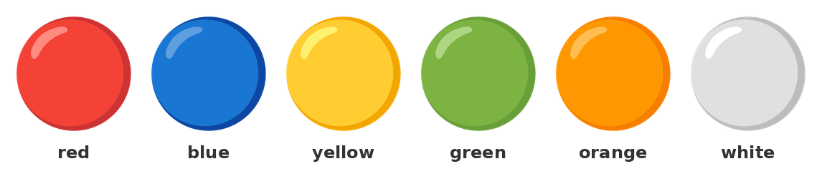
1) kırmızı = ?
A) red | B) blue | C) green | D) black
2) mavi = ?
A) yellow | B) blue | C) orange | D) pink
3) sarı = ?
A) green | B) yellow | C) white | D) purple
4) yeşil = ?
A) blue | B) brown | C) green | D) grey
5) beyaz = ?
A) black | B) white | C) pink | D) orange
▶ A2. Numbers 0-100. Choose the correct number word.
6) 12 = ?
A) ten | B) twelve | C) twenty | D) two
7) 20 = ?
A) twelve | B) twenty | C) ten | D) two
8) 30 = ?
A) thirteen | B) thirty | C) three | D) forty
9) 50 = ?
A) fifteen | B) fifty | C) five | D) forty
10) 100 = ?
A) ten | B) hundred | C) ninety | D) sixty
▶ A3. Class objects. Choose the correct word.
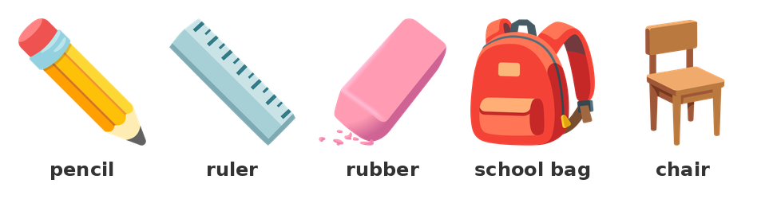
11) We write with a ___.
A) pencil | B) ruler | C) rubber | D) chair
12) We erase with a ___.
A) pen | B) rubber | C) book | D) door
13) We draw a line with a ___.
A) scissors | B) ruler | C) chair | D) window
14) We put our books in a ___.
A) school bag | B) board | C) rubber | D) pen
15) We sit on a ___.
A) table | B) chair | C) window | D) door
▶ A4. To be. Fill in the gaps with am, is or are.
16) I ________ a student.
17) She ________ my teacher.
18) They __________ in the classroom.
19) ___ you a student?
A) Am | B) Is | C) Are | D) Do
20) We are in the classroom.
( ) True ( ) False

Part B - Present Continuous + Lexis (20 Questions)
▶ B1. Present Continuous (affirmative). Fill in the gaps.
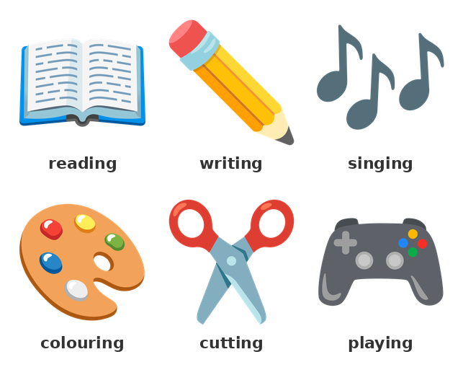
21) I ________________________ (read) a book.
22) She ________________________ (write) her name.
23) They __________________________ (play) a game.
24) He __________________________ (count) the numbers.
25) We ______________________________ (listen) to a song.
26) Look! The students ___ a picture.
A) colour | B) is colouring
C) are colouring | D) colours
27) What is she doing? She ___ a book.
A) read | B) reads
C) is reading | D) are reading
▶ B2. Present Continuous (negative, question). Fill in the gaps.
28) I __________________________________ (not / sleep).
29) He ______________________________ (not / run).
30) They __________________________________ (not / swim).
31) ___ she writing? Yes, she is.
A) Am | B) Is | C) Are | D) Do
32) Are they playing? No, they ___.
A) isn't | B) aren't | C) don't | D) are
▶ B3. Lexis. Choose the correct word.
33) Which day is the first school day?
A) Monday | B) Tuesday
C) Sunday | D) Friday
34) Which day comes after Monday?
A) Tuesday | B) Sunday
C) Friday | D) Monday
35) Which one is a school subject?
A) Maths | B) chair
C) window | D) rubber
36) Which one is a classroom object?
A) ruler | B) Monday
C) Maths | D) canteen
37) Which one is a school place?
A) library | B) pencil
C) English | D) Tuesday
▶ B4. Choose the correct answer.
38) We read books in the ___.
A) library | B) gym
C) canteen | D) office
39) We play in the ___.
A) library | B) playground
C) office | D) board
40) PE is a school subject.
( ) True ( ) False

Part C - WH Questions, To Be, Present Continuous (20 Questions)
▶ C1. WH question words. Choose the correct question word.
41) ___ is this? It is a ruler.
A) What | B) Where | C) When | D) Who
42) ___ is your teacher? She is in the classroom.
A) What | B) Where | C) Whose | D) Which
43) ___ book is this? It is Ali's book.
A) What | B) Where | C) Whose | D) How many
44) ___ students are there? Twelve students.
A) How many | B) What | C) Whose | D) Where
45) ___ is he doing? He is reading.
A) What | B) Whose | C) How many | D) Where
46) ___ is your name?
A) What | B) Whose | C) How | D) Where
47) ___ is she? She is my teacher.
A) Who | B) What | C) Whose | D) Where
▶ C2. To be. Fill in the gaps with am, is or are.
48) She ________ a teacher.
49) We __________ students.
50) ___ it a book? Yes, it is.
A) Am | B) Is | C) Are | D) Do
51) They ___ my friends.
A) am | B) is | C) are | D) be
52) I am in the classroom.
( ) True ( ) False
▶ C3. Present Continuous. Fill in the gaps.
53) He ________________________ (draw) a picture.
54) You ____________________________ (watch) a DVD.
55) What are you doing? I ___ my name.
A) write | B) am writing
C) writes | D) are writing
56) Is she singing? No, she ___.
A) isn't | B) aren't | C) don't | D) is
57) The students ______________________________ (colour) the picture.
58) What is he doing? He ___ a song.
A) sing | B) sings
C) is singing | D) are singing
▶ C4. Choose the correct answer.
59) Is Tom reading? No, he ___ a picture.
A) is drawing | B) reads
C) draw | D) is read
60) Can she sing? Yes, she ___ a song now.
A) sings | B) is singing
C) sing | D) can singing

