My Classroom / Part 2
3. Sınıf İngilizce, Unit 1: Ek Pekiştirme Çalışma Kağıdı
Ad Soyad: ..............................
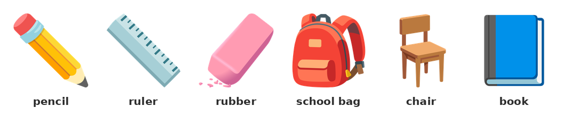
A. Classroom Objects
▶ Read the words, then complete the sentences with the words in the box.
1) 1. My books are in my ________________________ .
2. I draw a line with a ______________ .
3. I write with a ________________ .
4. Sit on a ______________ .
5. A ________________ is in my pencil case.
6. Look at my ____________ . It is blue.
Kelime bankası: chair | ruler | pencil | rubber | school bag | book

B. Classroom Instructions
▶ Match the instructions with their Turkish meanings.
2) Eşleştirin:
1. stand up | ( ) | A) dinle
2. sit down | ( ) | B) içeri gir
3. open your book | ( ) | C) ayağa kalk
4. close the door | ( ) | D) adını yaz
5. listen | ( ) | E) kapıyı kapat
6. look at the board | ( ) | F) tahtaya bak
7. write your name | ( ) | G) otur
8. come in | ( ) | H) kitabını aç

C. Verb to be: Questions and Short Answers
Soru sorarken verb to be başa gelir: It is a ruler. → Is it a ruler?
• Is it a pen? Yes, it is. / No, it isn't.
• Are they books? Yes, they are. / No, they aren't.
• Are you a student? Yes, I am. / No, I am not.
REMEMBER: Kısa cevapta 'Yes, it's.' kullanılmaz. Doğrusu: Yes, it is.

▶ Fill in the blanks with the correct form of 'to be'.
3) 1. ________ it a ruler?
Yes, it ________ .
2. __________ they pens?
No, they ________________ .
3. ________ this a school bag?
Yes, it ________ .
4. __________ you a student?
Yes, I ________ .
5. ________ it a chair?
No, it ______________ .

▶ Make a question from the words.
4) it / a pencil →
___________________________________________________________________________________________
5) they / books →
___________________________________________________________________________________________
6) you / a student →
___________________________________________________________________________________________

D. Numbers 1-20
▶ Write the missing number or word.
Number | Write in English | Word | Write the number
4 | ________ | eleven | ________
8 | ________ | fifteen | ________
12 | ________ | twenty | ________
16 | ________ | thirteen | ________
19 | ________ | seven | ________
20 | ________ | two | ________

E. Colours
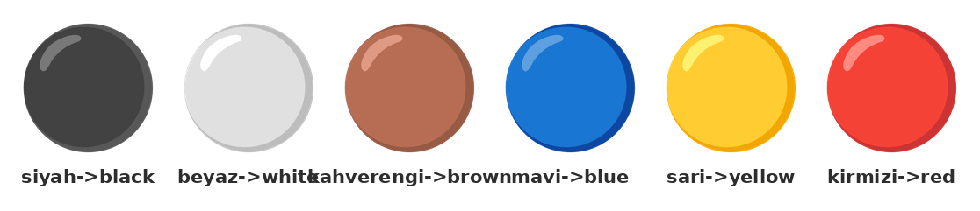
▶ Write the colour in English.
Object | Turkish | English
board | siyah | ________
window | beyaz | ________
door | kahverengi | ________
book | mavi | ________
pencil | sarı | ________
bag | kırmızı | ________

F. Multiple Choice
▶ Choose the correct answer.
7) ___ it a pencil? Yes, it is.
A) Are | B) Is | C) Am | D) It
8) Are they books? No, they ___ .
A) isn't | B) are | C) not | D) aren't
9) How ___ chairs are in the classroom? Twelve chairs.
A) many | B) is | C) are | D) a
10) I have got ___ orange pencil case.
A) a | B) two | C) an | D) the
11) Number 12 in English is ___ .
A) twenty | B) twelve | C) two | D) ten
12) ___ is this? It is a ruler.
A) How many | B) How | C) It | D) What
13) Look at the ___ . It is green.
A) table | B) board | C) door | D) window
14) Sit on the ___ .
A) chair | B) table | C) board | D) window

G. True or False
▶ Read and mark True or False.
15) 'Is it a pen?' is a question.
( ) Doğru ( ) Yanlış
16) 'Yes, it is.' is a short answer.
( ) Doğru ( ) Yanlış
17) 'How many' is for colour.
( ) Doğru ( ) Yanlış
18) Number 12 in English is 'twelve'.
( ) Doğru ( ) Yanlış
19) 'Sit down' is 'ayağa kalk'.
( ) Doğru ( ) Yanlış

H. Writing: My Classroom
▶ Look at the picture and write 5 sentences. Use 'This is a ___ .', 'It is ___ .' (colour) and 'I have got a ___ .'
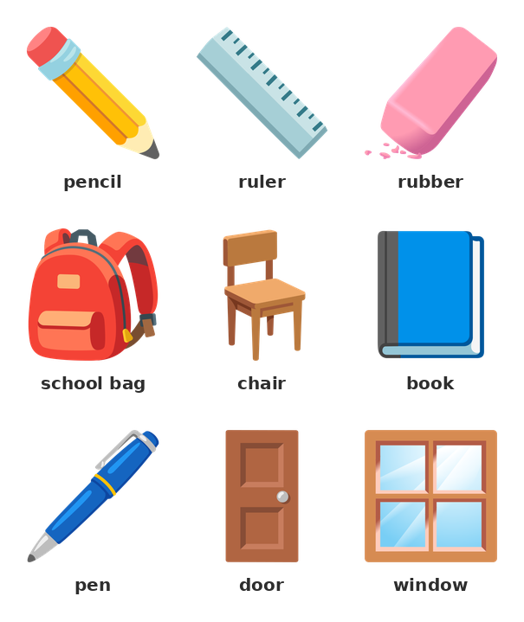
20) Write about your classroom.
___________________________________________________________________________________________
___________________________________________________________________________________________
___________________________________________________________________________________________
___________________________________________________________________________________________
___________________________________________________________________________________________
___________________________________________________________________________________________
___________________________________________________________________________________________

