My Classroom - Classroom Objects
3. Sınıf İngilizce | Unit 1: My Classroom
Ad Soyad: ..............................
▶ Look, read and complete.
A. Classroom Objects
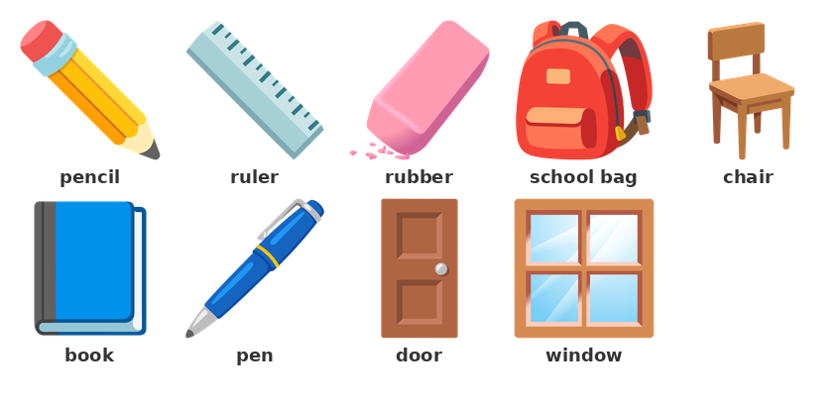
▶ Match the objects with the Turkish meanings.
1) Eşleştirin:
1. pencil | ( ) | A) kapı
2. ruler | ( ) | B) silgi
3. rubber | ( ) | C) okul çantası
4. school bag | ( ) | D) cetvel
5. chair | ( ) | E) kitap
6. book | ( ) | F) kurşun kalem
7. pen | ( ) | G) sandalye
8. door | ( ) | H) dolma kalem

▶ Fill in the blanks with the words in the box.
2) My books are in my ________________________ .
I draw a line with a ______________ .
I write with a ________________ .
I look at the ______________ . It is black.
Sit on the ______________ .
Open the ____________ .
Kelime bankası: board | ruler | pencil | chair | school bag | door

▶ Read and choose the correct answer.
3) I sit on it. What is it?
A) table | B) chair | C) board | D) door
4) I write with it. It is yellow and long. What is it?
A) pencil | B) ruler | C) pen | D) book
5) I look at it in the classroom. It is black. What is it?
A) door | B) book | C) board | D) bag
6) My books and my pens are in it. What is it?
A) ruler | B) school bag | C) chair | D) board
7) I draw a line with it. It is long. What is it?
A) rubber | B) pen | C) ruler | D) book
8) It is on the table. I read it. What is it?
A) desk | B) door | C) book | D) bag
9) I open it and I look out. What is it?
A) window | B) board | C) door | D) table
10) I have got it. It is blue. I write with it. What is it?
A) pen | B) rubber | C) pencil | D) ruler

▶ Write the name of the object.
11) I write with it. It is yellow. This is a ___ .
___________________________________________________________________________________________
12) My books are in it. This is a ___ .
___________________________________________________________________________________________
B. a / an
a pencil, a book, a ruler, a table | an orange, an object, an alphabet
REMEMBER: a + pencil, book, ruler, pen | an + orange, object, alphabet

▶ Fill in the blanks with a or an.
13) It is ________ pencil.
It is ________ orange.
I have got ________ ruler.
It is ________ object.
I have got ________ book.
It is ________ alphabet.
It is ________ door.
I have got ________ rubber.

▶ Choose a or an.
14) It is ___ pencil.
A) a | B) an | C) the | D) it
15) It is ___ orange.
A) a | B) the | C) an | D) and
16) I have got ___ ruler.
A) an | B) a | C) the | D) or
17) It is ___ object.
A) a | B) the | C) an | D) is
18) It is ___ book.
A) an | B) a | C) it | D) is
19) I have got ___ orange bag.
A) a | B) an | C) the | D) and

C. One or Many
one book, two books | one chair, three chairs | one pen, four pens
It is a book. They are books.
▶ Fill in the blanks with the correct form.
20) one book, two ______________ .
one ruler, three ________________ .
one chair, five ________________ .
one rubber, four __________________ .
one window, six __________________ .
one bag, two ____________ .

▶ Choose the correct answer.
21) One pencil, two ___ .
A) pencil | B) a pencil
C) pencils | D) the pencil
22) It is a chair. They are ___ .
A) chair | B) chairs
C) a chair | D) the chair
23) One book, two ___ .
A) book | B) books
C) a book | D) the book
24) I have got five ___ .
A) window | B) windows
C) a window | D) the window
25) It is a ruler. They are ___ .
A) ruler | B) a ruler
C) rulers | D) it

▶ Write the correct form.
26) one door, two ___ .
___________________________________________________________________________________________
27) one board, two ___ .
___________________________________________________________________________________________
D. This / That
This is a book. (yakında) | That is a door. (uzağımda)
• This is a pencil. (yakında)
• That is the board. (uzağımda)
• Is this a pen? Yes, it is. / No, it isn't.
• Is that a door? Yes, it is. / No, it isn't.
REMEMBER: 'Yes, it is.' is correct. 'Yes, it's.' is not correct.

▶ Fill in the blanks with this or that.
28) ____________ is my pencil. (yakında)
____________ is the board. (uzağımda)
____________ is a book. (yakında)
____________ is the door. (uzağımda)
____________ is my rubber. (yakında)
____________ is the window. (uzağımda)

▶ Fill in the blanks.
29) Is this a pen? Yes, it ________ .
Is that a board? No, it ______________ .
Is this a ruler? Yes, it ________ .
Is that a window? No, it ______________ .
Is this a book? Yes, it ________ .
Is that a door? No, it ______________ .

▶ Choose the correct answer.
30) ___ is my pencil. (yakında)
A) This | B) That | C) They | D) It
31) ___ is the board. (uzağımda)
A) This | B) That | C) They | D) The
32) Is this a ruler? Yes, it ___ .
A) is | B) isn't | C) are | D) am
33) Is that a door? No, it ___ .
A) is | B) isn't | C) aren't | D) are

▶ Make a question.
34) this / a pen →
___________________________________________________________________________________________
35) that / a book →
___________________________________________________________________________________________
36) this / a chair →
___________________________________________________________________________________________
37) that / a window →
___________________________________________________________________________________________
E. Colours and Numbers
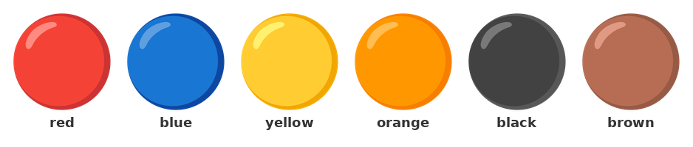
▶ Write the colour in English.
Object | Turkish | English
pencil | sarı | ________
board | siyah | ________
door | kahverengi | ________
book | mavi | ________
bag | kırmızı | ________
window | beyaz | ________

▶ Write the number in English.
38) 11 → ________________
12 → ________________
15 → __________________
18 → ____________________
20 → ________________
13 → ____________________

▶ Choose the correct answer.
39) ___ is the board? It is black.
A) What colour | B) How many
C) What | D) This
40) How many ___ ? Six pencils.
A) pencil | B) pencils
C) a pencil | D) the pencil
41) Number 15 in English is ___ .
A) five | B) fifteen | C) four | D) fourteen
42) Number 20 in English is ___ .
A) twelve | B) two | C) twenty | D) ten
43) ___ pencils are in my bag? I have got four pencils.
A) How many | B) What colour
C) What | D) This
44) Number 12 in English is ___ .
A) twenty | B) twelve | C) two | D) ten

▶ Write the number in English.
45) 7 → ___
___________________________________________________________________________________________
46) 19 → ___
___________________________________________________________________________________________
47) 14 → ___
___________________________________________________________________________________________
F. I have got
I have got a pen. | I have got two books.
EXAMPLE
I / have got / a pencil
Çözüm:
1. I have got a pencil.

▶ Fill in the blanks.
48) I have __________ a pen.
I ____________ got a book.
I have got ________ orange bag.
I have __________ two rulers.
I have __________ three pencils.

▶ Make sentences with I have got.
49) I / have got / a pencil →
___________________________________________________________________________________________
50) I / have got / two books →
___________________________________________________________________________________________
51) I / have got / a ruler and a rubber →
___________________________________________________________________________________________
52) I / have got / an orange school bag →
___________________________________________________________________________________________

▶ Choose the correct answer.
53) I ___ got a pencil.
A) have | B) has | C) am | D) is
54) I have got ___ book.
A) an | B) a | C) the | D) two
55) I have got ___ orange rubber.
A) a | B) an | C) the | D) or
56) I have got two ___ .
A) book | B) books
C) a book | D) the book
G. Questions
▶ Choose the correct answer.
57) This is a ruler. They are ___ .
A) ruler | B) rulers
C) a ruler | D) the ruler
58) ___ is the window. (uzağımda)
A) This | B) That | C) They | D) It
59) Number 18 in English is ___ .
A) eight | B) eighteen | C) eleven | D) ten
60) I have got ___ orange pencil.
A) a | B) an | C) the | D) two
61) ___ is this? It is a pencil.
A) How many | B) What
C) What colour | D) This

▶ Read and mark True or False.
62) 'This is a book.' is correct.
( ) Doğru ( ) Yanlış
63) 'I have got a pen.' means 'Benim bir kalemim yok.'
( ) Doğru ( ) Yanlış
64) Number 12 in English is 'twelve'.
( ) Doğru ( ) Yanlış
65) 'How many' is for colour.
( ) Doğru ( ) Yanlış
66) 'They are books.' is correct.
( ) Doğru ( ) Yanlış

H. Writing
▶ Look at the picture. Write 5 sentences. Use 'This is a ___ .', 'It is ___ .' and 'I have got a ___ .'
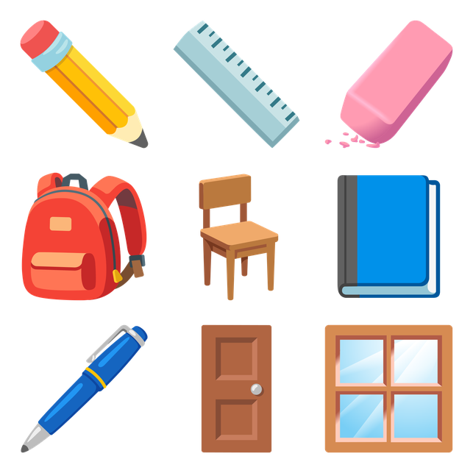
67) Write about your classroom.
___________________________________________________________________________________________
___________________________________________________________________________________________
___________________________________________________________________________________________
___________________________________________________________________________________________
___________________________________________________________________________________________
___________________________________________________________________________________________

