This / That - Sınıf Eşyaları
3. Sınıf İngilizce | Unit 1: My Classroom
Ad Soyad: ..............................
A. This / That (Konu Anlatımı)
This = yakınımdaki bir şey. That = uzağımdaki bir şey.
• This is a pen. (yakında)
• That is the board. (uzağımda)
• Is this a ruler? Yes, it is. / No, it isn't.
• Is that a door? Yes, it is. / No, it isn't.
PÜF NOKTASI: Kısa cevap: 'Yes, it is.' | 'Yes, it's.' değil. | Olumsuz: 'No, it isn't.'

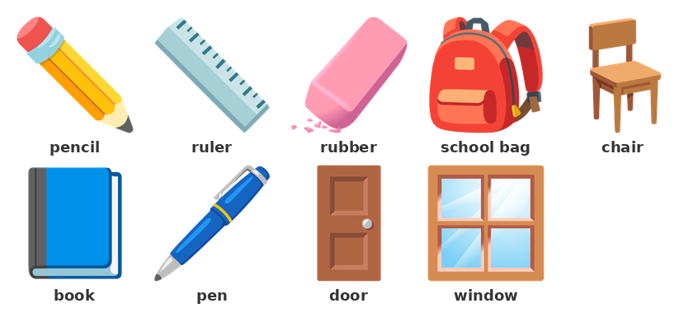
B. Boşluk Doldurma
▶ Boşlukları This veya That ile doldurun.
1) ____________ is my pencil. (yakında)
____________ is the board. (uzağımda)
____________ is a book. (yakında)
____________ is the door. (uzağımda)
____________ is my rubber. (yakında)
____________ is the window. (uzağımda)
▶ Kısa cevapları tamamlayın.
2) Is this a pen? Yes, it ________ .
Is that a board? No, it ______________ .
Is this a ruler? Yes, it ________ .
Is that a window? No, it ______________ .
Is this a book? Yes, it ________ .
Is that a door? No, it ______________ .

C. Cümle Kurma
▶ Kelimeleri kullanarak soru kurun.
3) this / a pen →
___________________________________________________________________________________________
4) that / a book →
___________________________________________________________________________________________
5) this / a chair →
___________________________________________________________________________________________
6) that / a window →
___________________________________________________________________________________________

D. Doğru Cevabı Seçin
▶ Doğru seçeneği işaretleyin.
7) ___ is my pencil. (yakında)
A) This | B) That | C) They | D) It
8) ___ is the board. (uzağımda)
A) This | B) That | C) They | D) The
9) Is this a ruler? Yes, it ___ .
A) is | B) isn't | C) are | D) am
10) Is that a door? No, it ___ .
A) is | B) isn't | C) aren't | D) are
11) This ___ a chair.
A) are | B) is | C) am | D) be
12) That ___ a window.
A) are | B) am | C) is | D) be
13) ___ this a pen? Yes, it is.
A) Is | B) Are | C) Am | D) Be
14) ___ is that? It is a door.
A) How many | B) What
C) This | D) That

E. Eşleştirme
▶ Nesneleri Türkçe karşılıklarıyla eşleştirin.
15) Eşleştirin:
1. pen | ( ) | A) cetvel
2. pencil | ( ) | B) dolma kalem
3. book | ( ) | C) kapı
4. ruler | ( ) | D) kitap
5. rubber | ( ) | E) kurşun kalem
6. chair | ( ) | F) pencere
7. door | ( ) | G) sandalye
8. window | ( ) | H) silgi

F. Doğru mu / Yanlış mı?
▶ Doğru ise (D), yanlış ise (Y) işaretleyin.
16) 'This is a book.' is correct.
( ) Doğru ( ) Yanlış
17) 'That is' → (yakında).
( ) Doğru ( ) Yanlış
18) 'Is this a pen?' is a question.
( ) Doğru ( ) Yanlış
19) 'Yes, it's.' is a correct short answer.
( ) Doğru ( ) Yanlış

