How many? - Sayılar 1-20
3. Sınıf İngilizce | Unit 1: My Classroom
Ad Soyad: ..............................
A. How many? (Konu Anlatımı)
How many = kaç tane? Cevap bir sayıdır.
• How many books have you got? Five books.
• How many rulers are on the table? Three rulers.
PÜF NOKTASI: 'How many' sayı sorar. 'What' ise nesneyi sorar: 'What is this? It is a pen.'

Sayı | İngilizce | Sayı | İngilizce
1 | one | 11 | eleven
2 | two | 12 | twelve
3 | three | 13 | thirteen
4 | four | 14 | fourteen
5 | five | 15 | fifteen
6 | six | 16 | sixteen
7 | seven | 17 | seventeen
8 | eight | 18 | eighteen
9 | nine | 19 | nineteen
10 | ten | 20 | twenty

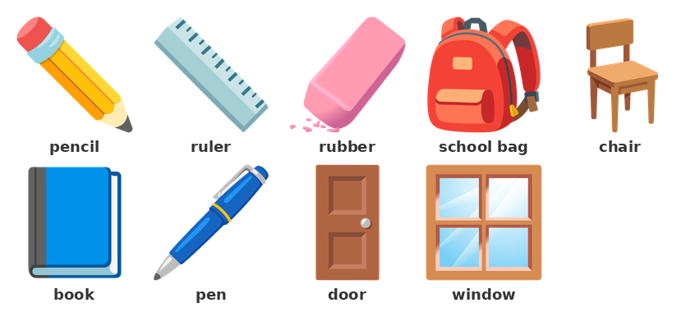
B. Sayılar
▶ Boşlukları İngilizce yazın.
1) 11 → ________________
12 → ________________
15 → __________________
18 → ____________________
20 → ________________
13 → ____________________

C. Boşluk Doldurma
▶ Boşlukları How many / What ile doldurun.
2) ____________________ books have you got? Five books.
____________ is this? It is a pen.
____________________ rulers are on the table? Three rulers.
____________ is that? It is a board.
▶ Sayın ve boşluğu sayıyla doldurun.
3) One, two, three, four. How many books? ____________ books.
I have got six pencils. How many pencils? __________ pencils.
One, two, three, four, five. How many chairs? ____________ chairs.

D. Doğru Cevabı Seçin
▶ Doğru seçeneği işaretleyin.
4) ___ books have you got? Five books.
A) What | B) How many
C) Which | D) How
5) Number 15 in English is ___ .
A) five | B) fifteen | C) four | D) fourteen
6) Number 20 in English is ___ .
A) twelve | B) two | C) twenty | D) ten
7) I have got five crayons and three pens. How many crayons? ___
A) three | B) five
C) eight | D) ten
8) Number 12 in English is ___ .
A) twenty | B) twelve | C) two | D) ten
9) ___ pencils are in my bag? I have got four pencils.
A) How many | B) What
C) This | D) Which
10) Number 11 in English is ___ .
A) one | B) eleven | C) ten | D) twelve
11) ___ is this? It is a ruler.
A) How many | B) What
C) Which | D) How

E. Doğru mu / Yanlış mı?
▶ Doğru ise (D), yanlış ise (Y) işaretleyin.
12) 'How many' is for colour.
( ) Doğru ( ) Yanlış
13) Number 12 in English is 'twelve'.
( ) Doğru ( ) Yanlış
14) 'How many books have you got?' is a question.
( ) Doğru ( ) Yanlış
15) Number 15 in English is 'five'.
( ) Doğru ( ) Yanlış

