I have got - Ait Olma
3. Sınıf İngilizce | Unit 1: My Classroom
Ad Soyad: ..............................
A. I have got (Konu Anlatımı)
I have got a pen. | I have got two books.
• Olumlu: I / You / We / They have got · He / She / It has got
• Olumsuz: I haven't got a pen. · He hasn't got a ruler.
• Soru: Have you got a pen? Yes, I have. / No, I haven't.
• Soru: Has she got a ruler? Yes, she has. / No, she hasn't.
PÜF NOKTASI: he / she / it → has got / hasn't got. I / you / we / they → have got / haven't got. Soru: Have / Has ... got?

EXAMPLE
I / not / have got / a pencil → (olumsuz)
Çözüm:
1. I haven't got a pencil.

EXAMPLE
she / have got / a book → (soru)
Çözüm:
1. Has she got a book?

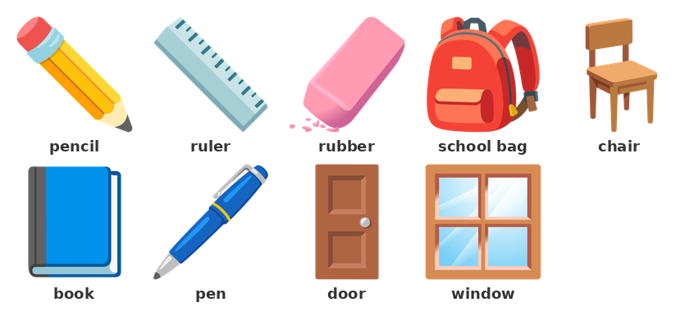
B. Boşluk Doldurma — Olumlu (have / has got)
▶ Boşlukları have / has / got ile doldurun.
1) I ____________ got a pen.
I have __________ a book.
He __________ got a ruler.
She __________ got a pencil case.
They ____________ got books.
I have got ________ orange bag.
C. Olumsuz — haven't got / hasn't got
▶ Boşlukları haven't / hasn't ile doldurun.
2) I __________________ got a pen.
He ________________ got a ruler.
They __________________ got books.
She ________________ got a pencil case.
We __________________ got a bin.
It ________________ got a name.
▶ Olumsuz kısa cevapları tamamlayın.
3) Have you got a ruler? No, I __________________ .
Has she got a book? No, she ________________ .
Have they got a bin? No, they __________________ .
Has he got a pen? No, he ________________ .

D. Soru — Have / Has ... got?
▶ Boşlukları Have / Has ile doldurun.
4) ____________ you got a pen?
__________ she got a ruler?
____________ they got books?
__________ he got a pencil case?
____________ we got a bin?
__________ it got a name?
▶ Sorulara kısa cevap yazın.
5) Have you got a book? Yes, I ____________ .
Has he got a ruler? Yes, he __________ .
Have they got a bin? No, they __________________ .
Has she got a pen? No, she ________________ .

E. Cümle Kurma
▶ Kelimeleri kullanarak cümle kurun.
6) I / have got / a pencil →
___________________________________________________________________________________________
7) He / have got / a ruler →
___________________________________________________________________________________________
8) I / have got / two books →
___________________________________________________________________________________________
9) they / not / have got / a table →
___________________________________________________________________________________________
10) he / not / have got / a book →
___________________________________________________________________________________________
11) you / have got / a ruler → (soru)
___________________________________________________________________________________________
12) she / have got / a pen → (soru)
___________________________________________________________________________________________

F. Doğru Cevabı Seçin
▶ Doğru seçeneği işaretleyin.
13) I ___ got a pencil.
A) have | B) has | C) am | D) is
14) He ___ got a ruler.
A) have | B) is | C) has | D) are
15) She ___ got a book. (olumsuz)
A) haven't | B) hasn't | C) isn't | D) aren't
16) They ___ got books. (olumsuz)
A) hasn't | B) haven't | C) isn't | D) aren't
17) ___ you got a pen?
A) Have | B) Has | C) Is | D) Are
18) ___ she got a ruler?
A) Have | B) Is | C) Has | D) Are
19) Has he got a book? No, he ___ .
A) has | B) hasn't | C) have | D) haven't
20) Have they got a bin? No, they ___ .
A) haven't | B) hasn't | C) isn't | D) aren't
21) I have got ___ book.
A) an | B) a | C) the | D) two
22) I have got ___ orange rubber.
A) a | B) an | C) the | D) or

G. Doğru mu / Yanlış mı?
▶ Doğru ise (D), yanlış ise (Y) işaretleyin.
23) 'I have got a pen.' is correct.
( ) Doğru ( ) Yanlış
24) 'He have got a ruler.' is correct.
( ) Doğru ( ) Yanlış
25) 'She hasn't got a book.' → (olumsuz).
( ) Doğru ( ) Yanlış
26) 'Have you got a pen?' is a question.
( ) Doğru ( ) Yanlış
27) 'No, I haven't.' is a correct short answer.
( ) Doğru ( ) Yanlış
28) 'I have got a pen.' means 'Benim bir kalemim yok.'
( ) Doğru ( ) Yanlış

